NORTON CIRCUIT

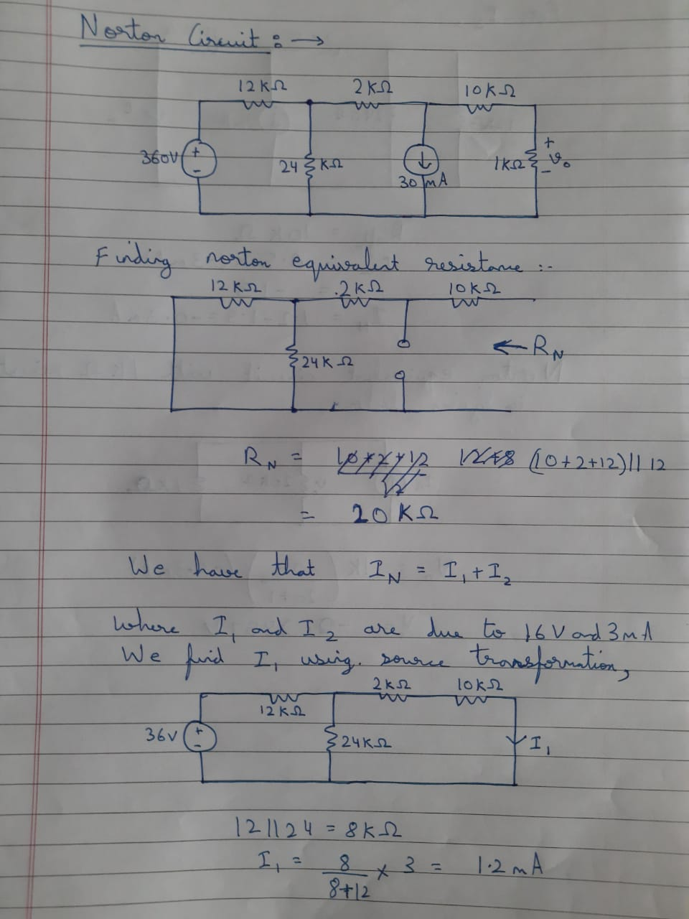

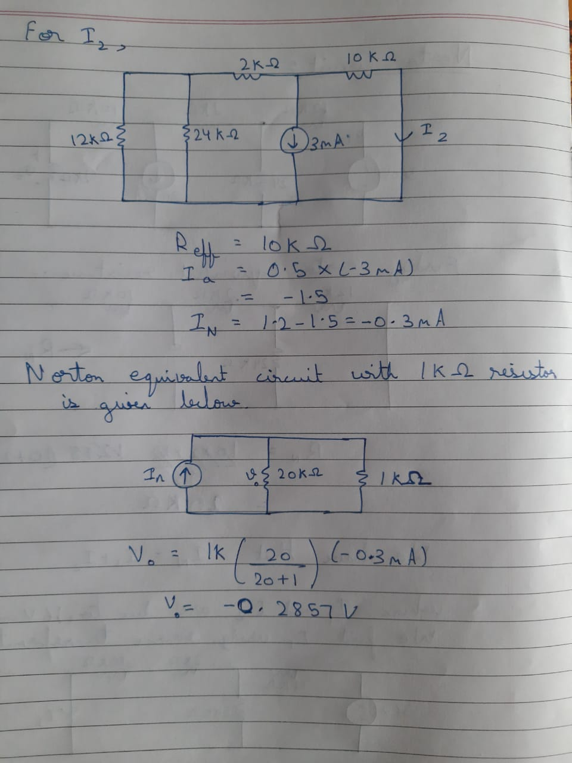

We obtain voltage across 20k ohm resistor to be -0.2857 by Norton Theorem:

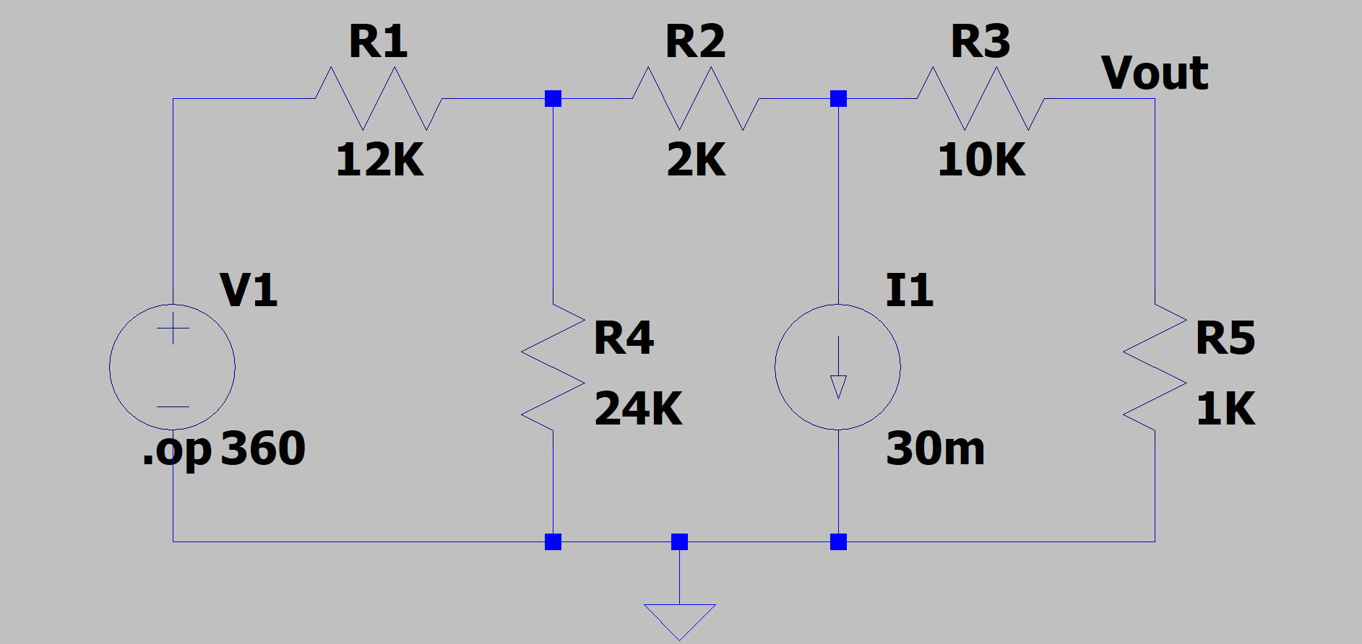

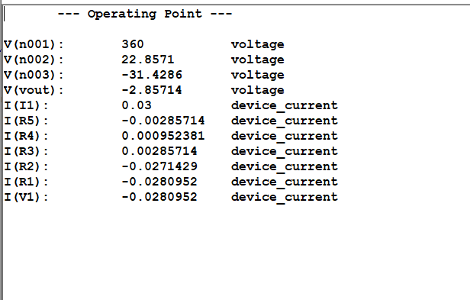

Finding the Norton Equivalent Resistance:

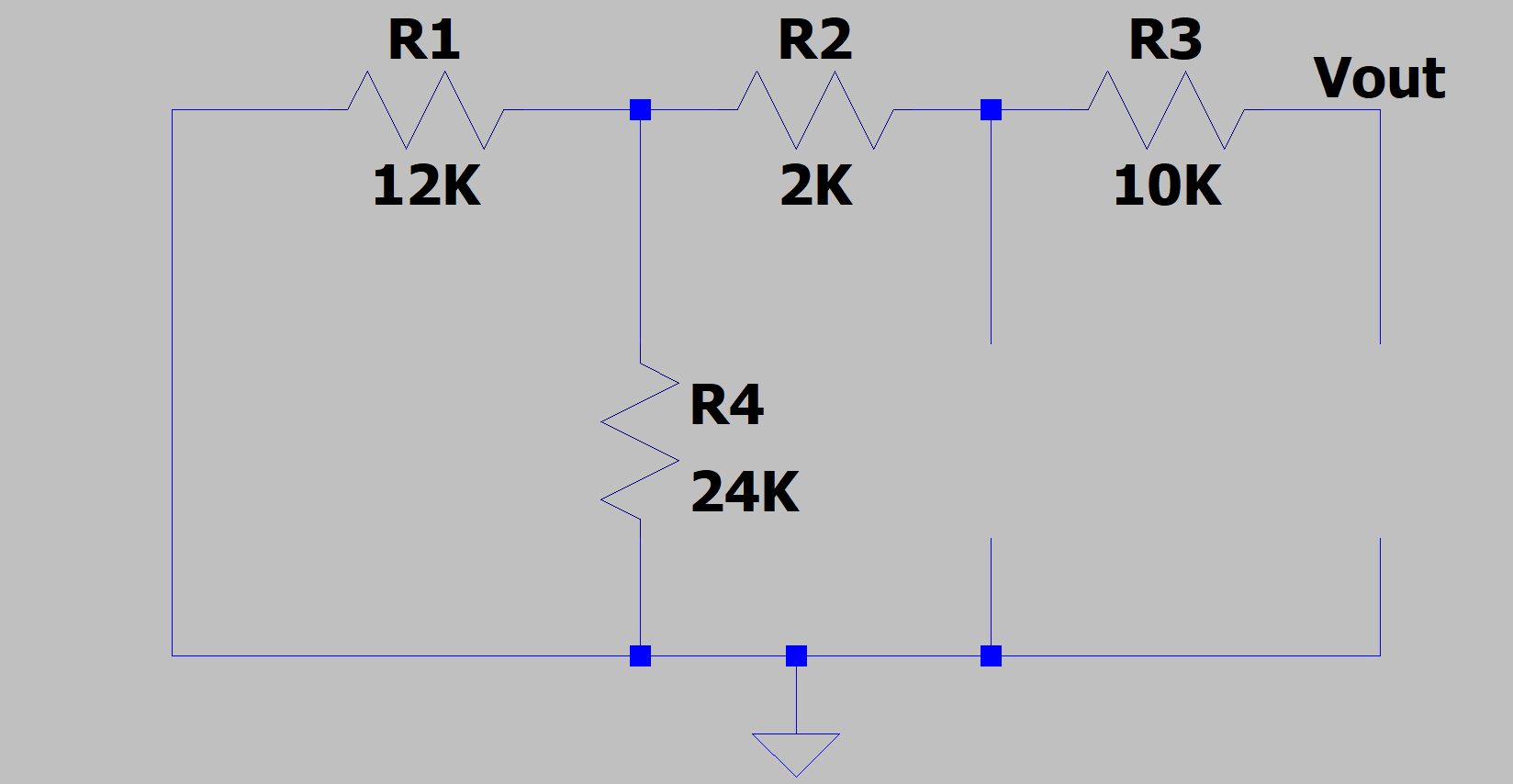

The Norton Equivalent Resistance is = 20K ohm.

We can use superposition theorem to find IN. Let IN = I1 + I2, where I1 and I2 are due to 16-V and 3-mA sources respectively. We find I using the circuit below.

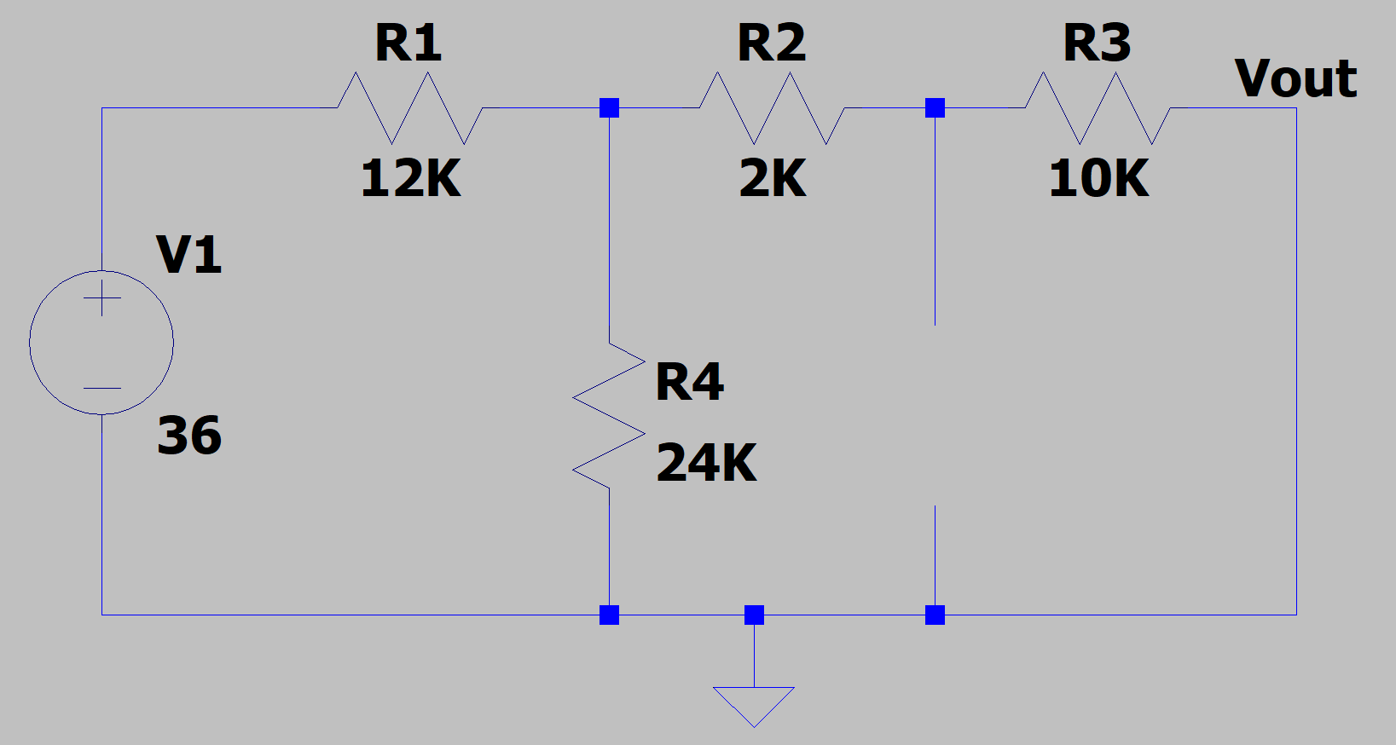

Using source transformation, we obtain the circuit below.

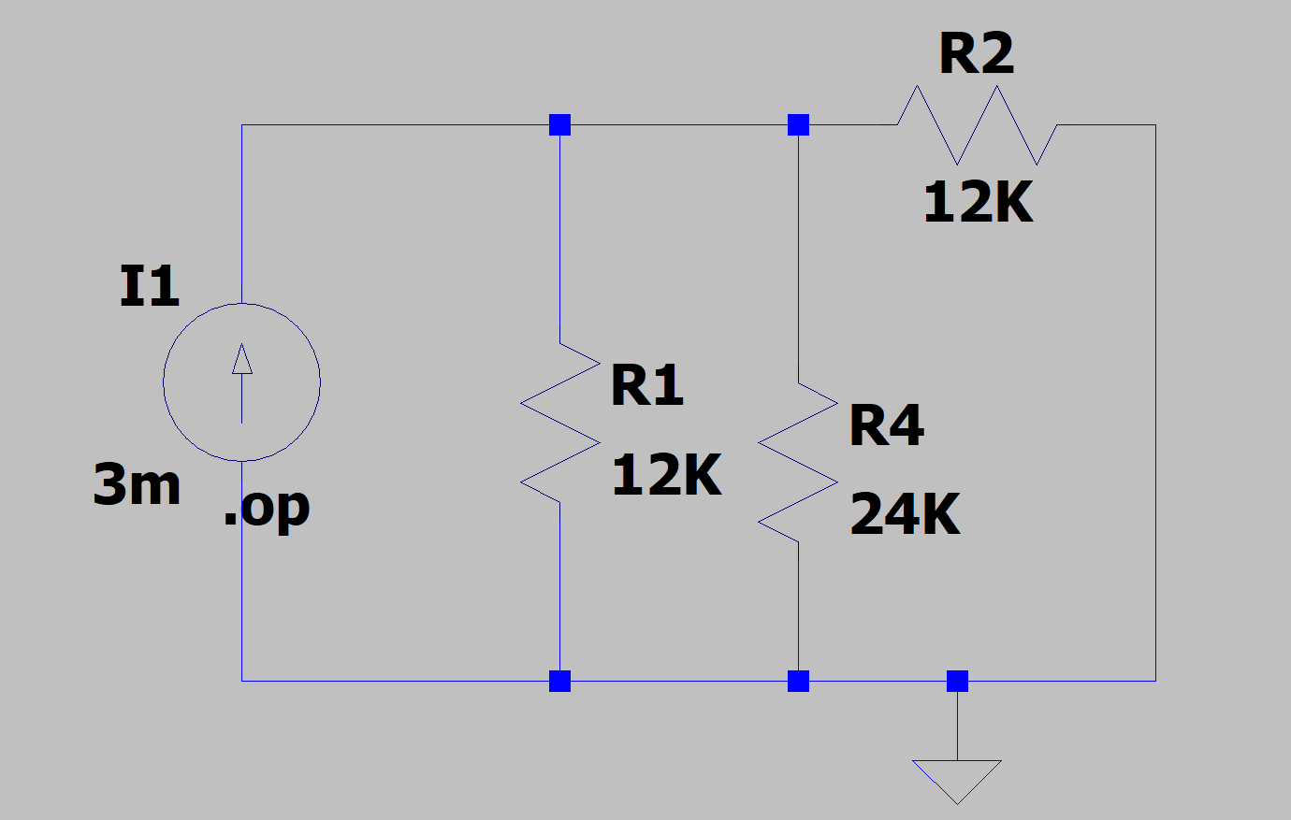

For finding I2 we use the Circuit:

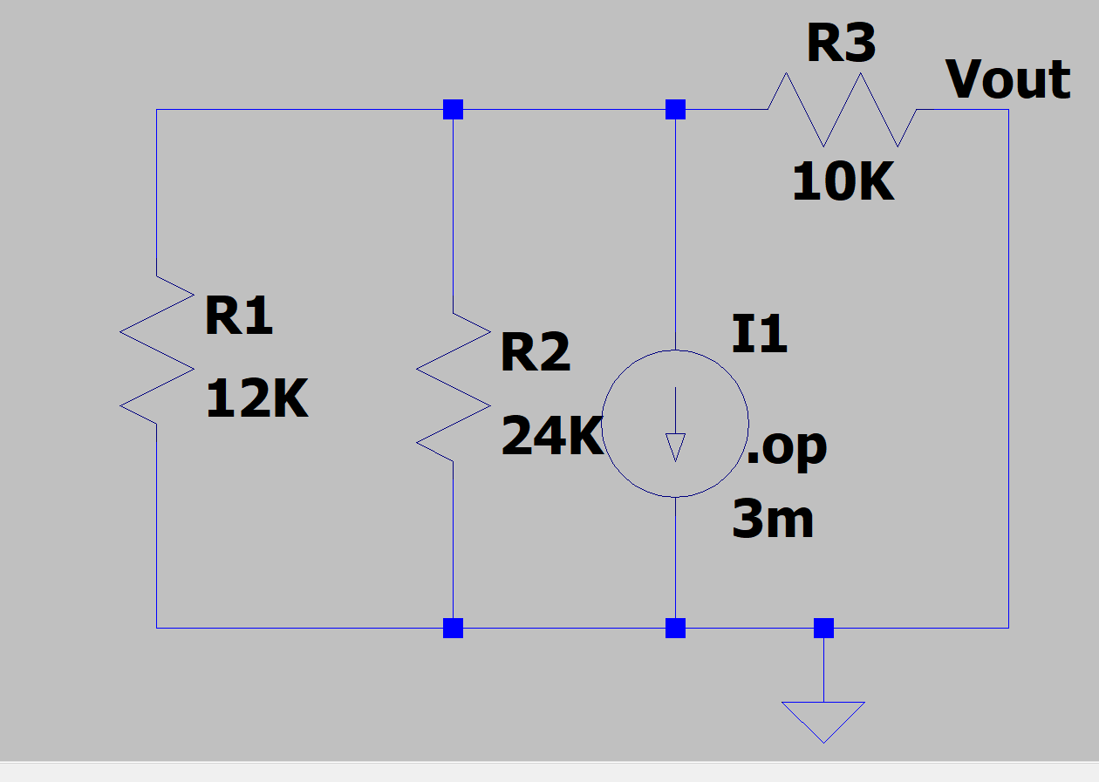

R efficient of this circuit = 10K ohm

Norton Equivalent Circuit is:

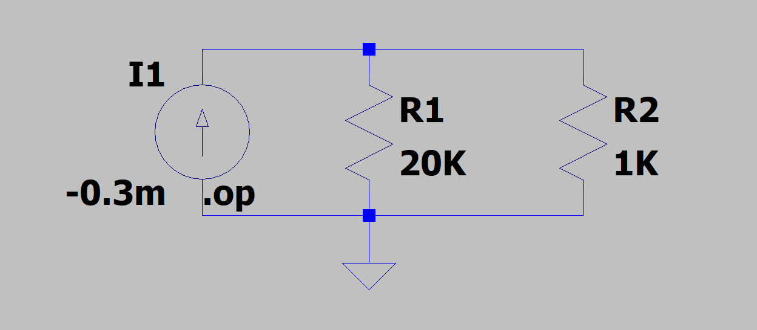

The voltage across 20 k ohm resistor is therefore which matches with our theoretical value:

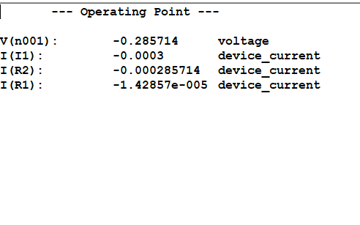

V0=-0.2857V

Hence theoretical and LT spice voltage across the resistor 20k ohm match by Norton’s Theorem.